LEWISHAM HOMES VOID DECORATION FORM
Decs Voucher No.
NAME: LEWISHAM HOMES

ADDRESS: OLD TOWN HALL

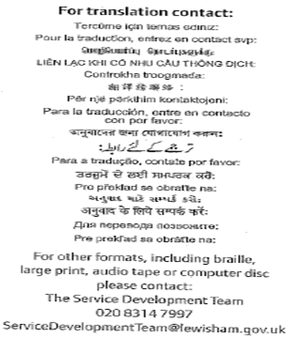

AUTHORISED OUTLETS
Homebase  10 Beckenham Hill Road  Catford SE6 3NU  Tel: 020 8697 8511  OR  Homebase  241 Kidbrooke Park Road,  SE3 9PP  Tel: 020 8856 9122 | 45 Oakfield Road  Penge  SE20  Tel: 020 8659 7331 | Sydenham DIY  Kirkdale  Sydenham SE26  020 8776 7020
 | New Hardware Centre  117 New Cross Road  SE14 5DJ  Tel: 020 7639 2105 | The Handy Stores  19 Leegate  Lee SE12 8SS  Tel: 020 8318 1013
Homecare DIY  136 Burnt Ash Road  Lee Green SE12 8PU  Tel: 020 8852 0344 | 22 – 23 Greens End  Woolwich  SE18  Tel: 020 8854 2599 | Turners Store  309 Brockley Road  SE4  Tel: 020 8692 1304

PAINT/WALLPAPER |  |  | DECORATING TOOLS |  |  |  | SUNDRIES
Primers |  |  | Paint Scraper |  |  |  | Fillers & Abrasives
Paint Pod & Paint |  |  | Wallpaper Edger |  |  |  | All Sealants
Undercoat |  |  | Filler Knife |  |  |  | PVA
Gloss |  |  | Safety Knife |  |  |  | Putty
Emulsion |  |  | Stripping Knife |  |  |  | Grout
Textured |  |  | Varnish & Paint Removers |  |  |  | Adhesives
Aertex |  |  | Mould Cleaner |  |  |  | Handy Packs (Inc screws & nails)
Lacquers |  |  | Tile Cutter
Masonry |  |  | Wallpaper Stripper
Anti-Damp |  |  | Wallpaper Scourers |  |  |  | CLEANING
Wood Care Treatment |  |  | Grout Spreader |  |  |  | White Spirits
Lining Paper |  |  | Dust Sheets |  |  |  | Brush Restorer
Wall Coverings |  |  | Pasting Board |  |  |  | Turps Substitute
Embossed |  |  | Small Step Ladder |  |  |  | Methyalated Sprits
Wood Chip |  |  | Electric Wallpaper Stripper |  |  |  | Sugar Soap
Boarders |  |  | Masking Tape |  |  |  | Detergents
Stencils |  |  | Rollers & Trays |  |  |  | Wallpaper Stripper
 |  |  | Brushes
 |  |  | Paste
TILES |  |  | Paste Bucket |  |  |  | ABRASIVES
 |  |  |  |  |  |  | Glass Paper
Kitchen & Bathroom Wall Tiles |  |  |  |  |  |  | Sander Sheets
Kitchen & Bathroom Floor Tiles |  |  |  |  |  |  | Steel Wool
Carpet Tiles
 | LAMINATE FLOORING, POWER TOOLS, SHELVES ARE NOT INCLUDED IN THE SCHEME

